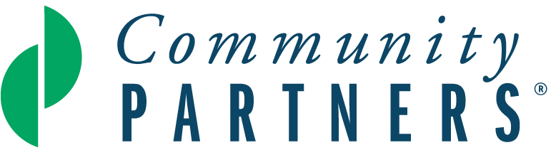

Proposal Narrative

Please use the following questions to develop your proposal for fiscal sponsorship. We ask that you limit your narrative to no more than 10 pages. The page ranges suggested below are intended to give applicants a sense of where to focus their attention.

- Project Description: What does your project do? (1½-3 pages)

Please include:
- Your project’s mission
- Target population
- What geographic community it serves
- The number of people your project serves
- Your specific project activities: what they are, who carries them out, where they take place, and how often they take place (Details are important here)

- Project History: Why was this project initiated? (1-2 pages)

Please describe:
- When your project was launched and who was involved in getting it started
- The need(s) the project was created to address
- The strengths and capabilities of the project’s target population and how you are engaging this community to increase your project’s likely impact
- How your project differs from other organizations that address the same or similar issues
- The work you have done to research, design, pilot test or demonstrate the project

- Project Goals: What are you hoping to achieve? (½ -1 page)

Describe what you realistically hope to accomplish by the end of your first year under fiscal sponsorship. Please keep in mind potential time and/or fiscal constraints. It’s okay to be candid here!

- Project Impact: How will you know your project has made a difference? (1- 1½ pages)

Provide some detail about:
- How you will measure the effects of your project’s activities on the community it serves at the end of your first year under fiscal sponsorship
- Any significant accomplishments to date

- Project Leadership: Who will help you carry out your project’s mission? (2-3 pages)

To complete your project sponsorship application you will need to submit résumés for the primary people conducting project activities in addition to answering this question for the Proposal Narrative.

Please include:
- A description of the work-related, volunteer or other experiences you and other key people have had that will help you lead your project
- Summary biographies for each person you plan to include on your advisory board, which should contain at least three people. Be sure to indicate whether each person identified has already agreed to serve on your project advisory board.
- Names and descriptions of any additional people who will be working with you most closely as volunteers and/or staff
- Your current key relationships with allies, in your community and elsewhere, who are necessary for your project’s success

- Fundraising and Project Budget: How will you fund your project’s activities? (1-2 pages)

Note that this question should be answered in the proposal narrative in addition to completing a one-year budget and budget narrative that details sources of revenue and expenses for your project.

Please describe:
- Your specific revenue goals and plans for raising funds from sources such as individual donors, foundations, businesses/corporations, government, special events and/or other sources. Include a projected timeline for carrying out these fundraising activities. If possible, identify likely funders for your particular efforts and indicate if you have a relationship with these potential funders or if they are prospects you intend to approach. Letters of support from potential individual, foundation, public, or corporate funders can be uploaded in addition to the proposal narrative if you have them.
- Your plans to develop non-financial resources such as in-kind donations, space for operations, and/or volunteer participation, if applicable

7. Relationship with Community Partners: How will fiscal sponsorship add value to your project? (¼ - ½ page)

Outline your specific expectations regarding the benefit(s) fiscal sponsorship and a relationship with Community Partners will provide your project.

