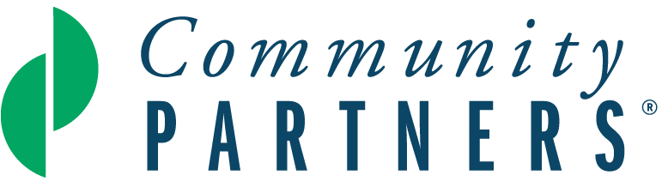

Proposal Narrative

Community Partners is home to creative ideas powered by innovative leaders. Together, we work to create more equitable, just, and vibrant communities. We invite you to share a compelling and colorful summary of your project with brevity, transparency, and candor.

- Please provide a brief overview of your project.
- What social issue is your project attempting to solve? How are people who experience the social issue involved in determining and implementing the solutions?
- Describe your project’s activities. How will your project’s work transform lives and/or systems?
- Who implements the activities, and when and where do they take place?
- Share the work you have done to research, design, pilot test or demonstrate the project. If none, please write n/a.

- Project Goals: What are you hoping to achieve?
- Realistically, what do you hope to accomplish by the end of your first year of fiscal sponsorship at Community Partners? Be specific.

- Project Impact: How will you measure your project’s impact at the end of your first year under fiscal sponsorship at Community Partners?
- How will you measure the impact of your project’s activities in the community you serve? Be specific.
- How are you accountable to the community you are serving?

- Equity: We prioritize support for projects that focus on dismantling inequity and/or advancing equity and accessibility, particularly by and for Black, Indigenous, and other People of Color (BIPOC) communities.

- How is your project advancing equity and/or dismantling inequity?
i. If this is not a priority of your project, how can Community Partners support
you with incorporating an equity lens into your work?
- What is the race and/or ethnicity of the proposed project leader(s)?
- What is the race and/or ethnicity of the community your project serves?
- To what extent do your project’s staff, volunteer leadership, and/or advisory board reflect the racial and/or ethnic identities of the community you serve? Are there other lived experiences (e.g., houselessness, disability, immigrant status, LGBTQIA+, survivors of violence) that are reflected both in your leadership and the community you serve? Please be specific.
- If your project is not serving BIPOC communities, how do you plan to incorporate equitable practices in your project? If your project is serving BIPOC communities, write n/a.
- Is there any historical significance about the community you serve you would like us to know? If yes, please explain.

- Project Leadership: Who will help you carry out your project’s mission?
- Briefly outline who the key people are in carrying out the project’s mission and list any related experiences.
- List each Advisory Board member and include 1-2 sentences describing their related work or volunteer experiences and/or relationships that will support your project’s success.
- Outline your current key relationships with allies, in your community and elsewhere, who contribute to your project’s success.

- Fundraising and Project Budget: How will you fund your project’s activities?
Note that this question should be answered in the proposal narrative in addition to completing a one-year budget that details sources of revenue and expenses for your project. (the required budget template can be found in the link below)

Please describe:
- Your specific revenue goals and plans for raising funds from sources such as individual donors, foundations, businesses/corporations, government, special events and/or other sources. Include a projected timeline for carrying out these fundraising activities.
- If possible, identify funders for your efforts and indicate if you have an existing relationship or if they are prospects you intend to approach. (Letters of support from potential individuals, foundation, public, or corporate funders can be uploaded in addition to the proposal narrative, if you have them.)
- Your plans to develop non-financial resources such as in-kind donations, space for operations, and/or volunteer participation, if applicable.

Relationship with Community Partners
- What services are you most excited about if fiscally sponsored by Community Partners?

Financial services (bill paying, financial reports, accounting, audit)
Capacity building (thought partnership, workshops, Meet the Funder sessions)
HR (payroll, benefits)
Grants and contracts administration
Community building (with other fiscally sponsored projects)
Other: ________________________

- Do you have any additional expectations regarding the benefits that fiscal sponsorship with Community Partners will provide for your project? If yes, please describe.

