Workplace Wellness Space Grants

Application Period: April 1– 26, 2024

GUIDELINES

OVERVIEW
The purpose of the Workplace Wellness Space Grants (WWSG) program is to provide up to $5,000 per workplace to create a wellness space. The grants will help workplaces set up dedicated wellness spaces for employee relaxation, safe social interaction and work collaboration to decrease stress levels and increase team building. Employees are looking for mental health and wellbeing support now more than ever before.
The grants are made possible through a partnership between Kaiser Permanente and the Oregon Educators Benefit Board (OEBB).
Be sure to register for the WWSG April 10, 2024, 3:30-4:30pm Application Webinar:
- Learn about the application process
- Learn tips for preparing a strong application
- Learn about tools/resources available for extra support
- To register for the webinar: 2024 KP OEBB Workplace Wellness Space Grants

APPLICATION SUPPORT: After reviewing this document, please contact Liz Schwarte at Liz@adlucemconsulting.com if you feel you need help preparing your application.
If you applied in the past and were not awarded a grant, we strongly encourage you to participate in the application webinar; please reach out to liz@adlucemconsulting.com for support to develop a strong application.

ELIGIBILITY
School districts/individual schools/workplaces that offer Kaiser Permanente health insurance through OEBB are eligible to apply. Applicants must be tax exempt.
While school district applications covering multiple schools will be prioritized for funding, individual schools may apply for the KP/OEBB Workplace Wellness Space Grants. If your district is not applying, please share these guidelines with the health/wellness leads and/or principals at the schools in your district.
Eligible applicants:
- School Districts
- Individual schools
- Public Charter Schools
- Education Service Districts
- Community Colleges
- Local government
  - City, County or Special District (per ORS 198)
Only one application per school district/individual school/workplace will be accepted and reviewed. Please work with the employees at your school district/individual school/workplace to determine what your workplace needs to create a wellness space and submit a single application. We will only review one application for each school district/individual school/workplace.
Although priority will be given to applicants not previously funded through this grant program, school districts/workplaces that were awarded a grant in previous grant cycles are eligible to reapply to reach additional schools/locations if they have successfully completed their past grant(s).

Applications from School Districts:
- School districts may apply to create wellness spaces at up to four individual schools.
- School districts must determine a shared approach to creating wellness spaces at the schools covered by the application and describe a plan for how the district will coordinate across the schools to implement grant activities and obtain supplies.
- Applications from school districts will receive priority in funding decisions.
Applications from Individual Schools:
- If you are an individual school applying for this grant a requirement is that you talk with a high-level district representative to get their approval for your application.
- In the application you will be asked to provide the name, title and contact information for the district representative that approved your application. We want to make sure that all grant applications are submitted in accordance with district policies.

APPLICATION GUIDELINES

Successful applications will describe:
- Clear, specific rationale for why the wellness space is needed including specific characteristics of the school/workplace and employees that will benefit from the wellness space
- Identified/designated employee only space approved by leadership
- Detailed steps that provide a clear understanding of what will be done to create and activate the wellness space
- If training/professional development is included, the application should include a clear description of why the training is needed and how it will support activation of the wellness space.
- Employees responsible for the creation of and maintenance, and communications for the space, providing a concrete plan that illustrates a clear path to project success
- How wellness space features will promote employee relaxation, interaction and collaboration
- Plan to maximize employee utilization of the wellness space
- Plan to maintain the wellness space over time
- For school districts: plans for taking full advantage of this funding to work in as many schools in your district as possible (up to four schools per grant cycle)

Wellness space requirements:
- Dedicated space for employees (adults only, no students)
- A separate room or a dedicated space (within an existing room) for wellness
- Wellness spaces must include a quiet area for meditation and/or mindfulness

Grant funds may be used to support:
- Wellness space renovations to create an appealing, calming environment (e.g., paint, floor coverings, window coverings, lighting, artwork)
- Furniture to facilitate safe interaction and team building (e.g., tables and chairs, couches)
- Equipment to facilitate relaxation and stress reduction (e.g., yoga supplies, light physical activity equipment, audiovisual equipment to play meditation videos, mindfulness podcasts, music)
- Training or professional development (in person or virtual) that enhances the benefits of the wellness space and leads to ongoing employee wellness and relaxation practices (e.g., a train-the-trainer workshop on mindfulness that includes a plan for periodic refresher trainings)

Grant funds are not allowed to support:
- Salary support for any employee
- One-time activities or events
- Food/water or food preparation/cooking equipment
- Supplies the workplace will not be able to purchase after the grant ends (e.g., essential oils)
- Incentives such as t-shirts, gift cards, water bottles or other promotional items

Grant Logistics:
- Grant awards are up to $5,000 per individual school/workplace or up to $20,000 per district for wellness spaces in up to four schools
- Grant implementation period: June 2024 - March 2025
- Application must be supported by leadership. In the application, you will be asked to submit a high-level administrator’s name and contact information as evidence of their approval for this project.
- Identify a project lead and administrative lead (if different).
- Only one application per school district/individual school/workplace.
- All grants will be administered by Community Partners, a partner organization with Kaiser Permanente and Ad Lucem Consulting.
- Grant funds will be distributed by Community Partners.
- If awarded a grant, grantees agree to:
- Complete brief progress and grant-end surveys describing how funds were used
- Participate in an interview to discuss the grant experience if requested
- Submit photographs and accompanying signed releases for promotional and informational materials, if requested
- Notify Kaiser Permanente about any planned media (e.g., press releases, articles), acknowledge Kaiser Permanente in media, and share media with Kaiser Permanente
- Display wellness posters provided by Kaiser Permanente in the wellness space
- Partner with Kaiser Permanente to share wellness space successes
- One year and three years after your grant ends, complete a brief survey on wellness space maintenance, utilization and technical assistance needs.

Required Documentation:
- Grant Budget. Click here to download the budget template.

Funds can go directly to tax exempt school districts/schools/workplaces or to a non-profit fiscal agent (such as a school district foundation). You will need to submit one of the following forms of documentation:
- IRS 501c3 Status Letter (for non-profit fiscal agents)
- Current tax-exempt determination letter from the Internal Revenue Service
- A letter from the Chief Financial Officer or a Certified Public Accounting Firm, indicating that the school district/workplace has been granted tax exemption
- A copy of the statute/charter or enabling legislation establishing the school district/workplace

Please click here to see the resources for developing an application. The resources are under the “Application Resources” tab.
If the link does not work, please copy and paste this URL into your browser:
https://communitypartners.org/landing-page/kaiser-permanente-oebb-guidelines/
SUBMISSION INSTRUCTIONS

The application submission period is from April 1 – April 26, 2024.
We highly recommend that you download and complete the Word version of the application prior to going to the online form. Please observe the word limits and red asterisks denoting required questions. When online, please copy and paste your answers into the online form from the Word version.
Prior to preparing your application, review the model budgets carefully.
Please note: If the model budget link does not work, please copy and paste this URL into your browser:
https://communitypartners.org/files/documents/KPOEBB/cycle3/Sample%20Budgets%202022.pdf

Ready to apply? Enter your online application when the link opens April 1, 2024.
PLEASE NOTE: You MUST use Google Chrome to properly access the Submittable application.

Please click here to view the Submittable FAQ for guidance on submitting your application online.
The grant application for Workplace Wellness Space Grants will be open from April 1, 2024 – April 26, 2024. Applicants will need to create a Submittable account to apply, and upload required documentation.

As you fill out the online application, you will be able to save and return to it at a later time.

Community Partners strongly recommends submitting the application at least 5 days before the deadline to give ample time to troubleshoot technical issues.

Complete applications are due by April 26, 2024, 5pm Pacific Time.

If you have any technical assistance questions, please contact Kahlil Gasper, Community Partners Senior Program Manager, at (213) 346-3200 ext. 296 or WorkplaceWellness@communitypartners.org.

APPLICATION
Please complete this statement: * I am submitting a proposal for (select only one):
School District
Individual School
Public Charter School
Education Service District
Community College
Local government
- City, County or Special District (per ORS 198)

Only tax exempt school districts/schools/workplaces that are insured though OEBB and offer Kaiser Permanente health insurance are eligible to apply.

My organization offers Kaiser Permanente health insurance through OEBB*
Yes No (not eligible to apply)
My school district/school/workplace is tax exempt: *
Yes No (not eligible to apply)

Applicant Information

Has your school district/school/workplace ever received a Workplace Wellness Space Grant?
Yes No
If yes, which years? (Check all that apply).
2019
2021
2022
2023
If your grant was awarded in 2023, what is the status of your Workplace Wellness Space project? (Select one.)
Completed
Mostly Done
Halfway Done
Initial Stages (NOTE: You are ineligible to apply for this grant cycle. Please do not complete an application.)

School District/
School/Workplace Name: *

Street Address: *
City: *
State: *
Zip: *
Phone Number: *
Will an organization serve as the fiscal agent (e.g. 501c3 such as school district foundation)? *
Yes
No
If yes, please provide us the following information below for the fiscal agent (all fields are required):
Organization Name: *
Street Address: *
City: *
State: *
Zip: *
Email: *
Phone Number: *
Note: You will need to attach one of the following:
- IRS 501c3 Status Letter (for non-profit fiscal agents)
- Current tax-exempt determination letter from the Internal Revenue Service.
- A letter from the Chief Financial Officer or a Certified Public Accounting Firm, indicating that the school district/workplace has been granted tax exemption.
- A copy of the statue/charter or enabling legislation establishing the school district/workplace.
To assure we have the necessary information if you are awarded a grant, please provide the name of the school district/school/workplace the check should be made out to including the tax identification number.
Make Check Payable to: *
Tax ID #: *

Project Lead

The project lead will serve as the main contact for this project, and if awarded, will oversee the activities described in the application.
Name: *
Title: *
Email: *
Phone Number: *
Will the project lead also be the fiscal/administrative lead? *
Yes No
If no, please provide us the contact information for the fiscal/administrative lead:
Name: *
Title: *
Email: *
Phone Number: *

Leadership Support

For district and workplace applicants other than individual schools:
Please submit the name of a high-level administrator (e.g. school district superintendent/assistant superintendent, dean, director) as an indication of their support and approval of this project.
Name: *
Title: *
Email: *
Phone Number: *

For individual school applicants:
- If you are an individual school applying for this grant, a requirement is that you talk with a high-level district representative to get their approval for your application. We want to make sure that all grant applications are submitted in accordance with district policies.

I have communicated with a high-level district representative and have the approval to submit this application.
Yes — Complete information below.
No — You are not eligible to complete this application

Please submit the name of a high-level district administrator (e.g. school district superintendent/assistant superintendent) as an indication of their support and approval of this project.
Name: *
Title: *
Email: *
Phone Number: *

Data
Individual Schools/Districts:
Note: If a school district is applying on behalf of up to four schools, please provide aggregate data for the schools included in the application:
Number of Schools: * |  | Enter a number only
Please list the schools included in the application. * |  | Example: ABC Elementary School, XYZ Middle School, and Our Town High School
Total Enrollment: * |  | Enter a number only
% Students Eligible for Free and Reduced Lunch: * |  | Enter a number only
Grades: * |  | Example: K-6
Total Number of Employees: * |  | Enter a number only

Workplaces:
Number of Employees: * |  | Enter a number only
Describe the unique characteristics of your employees: (e.g. non-English speakers, low wage earners, veterans, diverse ethnicities)* |  | Enter a number only

Grant Request
Grant awards are up to $5,000 per individual school/workplace. School districts applying on behalf of up to four schools must submit a request for all schools combined. Model Budgets:
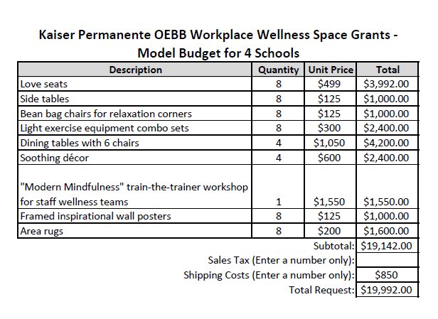
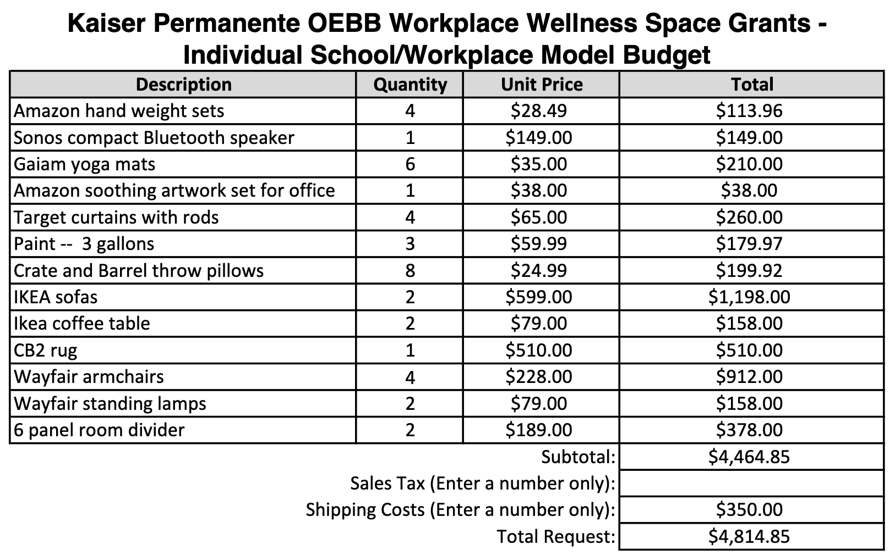
When using the online form, you will need to upload a budget (Click here to download the budget template) at the end of the application and indicate the total amount requested. Please note: If the link does not work, please copy and paste this URL into your browser:
https://communitypartners.org/sites/default/files/documents/kaiserpermanente/oebbworkplace2019/KP%20OEBB%20Wellness%20Grant%20Budget%20Template.xlsx
Make sure that your amount requested matches the budget you attach.
Amount Requested (Up to $5,000 per workplace): * |  | Enter a number only

Will you use other funds/in kind resources to implement this project? (Examples: grants, maintenance personnel, contributions from local businesses, etc.) *
Yes
No
If yes, describe the source of those funds or in-kind contributions: *
Word limit: 150
Describe why your workplace needs a wellness space: *
Identify the specific wellness needs of your workplace’s employees (e.g. employees experienced a traumatic event, high stress levels, lack of social interaction). If your application includes training/professional development, make sure to describe why this is needed to enhance the benefits of the workplace wellness space. Include any data (e.g. employee survey or health screening results) you have about your employees’ health/wellness.
Word limit: 250

List the specific step-by-step activities to create the wellness space (please use bullets): *
Only include activities that are feasible to implement within your grant budget within the implementation period.
School district applicants, please include: how you will determine a shared approach to creating wellness spaces at the schools covered under the application; plans for how the district will coordinate across the schools to implement grant activities and obtain supplies.
Word limit: 250

How will the wellness space support employee wellness and address the needs you described above? *
Describe how the wellness space you propose will reduce employee stress and promote safe relaxation, social interaction and collaboration. If you include training/professional development in your application, describe how it will contribute to reducing employee stress and promoting employee wellness.
Word limit: 250

Describe your plans to maximize use of the wellness space and how future employees will be oriented to using the wellness space.*
Word limit: 250

Describe your concrete plans to assure the wellness space is well maintained (e.g. regular cleaning, repairs are made, materials are kept organized, broken equipment is fixed) and describe who will be responsible. *
Word limit: 250

How will the wellness space change the culture/environment or priority placed on employee health/wellness at your workplace? If your application includes training/professional development, please describe how it will enhance the benefits of the workplace wellness space.*
Examples:
- The wellness space provides a welcoming, positive and peaceful place for staff.
- The majority of employees takes a daily mindfulness/meditation break in the wellness space.
- Leadership includes discussion of wellness space utilization/benefits at meetings.
Only include changes that are feasible to make within your grant budget during the eight-month implementation period.
#1* |  | Word limit: 25
#2* |  | Word limit: 25
#3 |  | Word limit: 25
#4 |  | Word limit: 25

How did you hear about this grant opportunity? (Check all that apply.) *
Email announcement
OEBB representative
School Employee Wellness Conference
OEA Choice Trust
Kaiser Permanente representative
Other: _______________________________________________________

Please note: You will be asked to upload required documents at the very end of the online application form.

