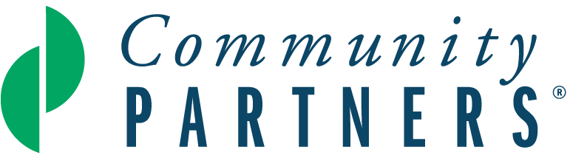

# Proposal Narrative

Community Partners is home to creative ideas powered by innovative leaders. Together, we work to create more just and vibrant communities. We invite you to share a compelling and colorful summary of your project with brevity, transparency, and candor.

1. **Please provide a brief overview of your project.**
2. What social issue is your project attempting to solve? How are people who experience the social issue involved in determining and implementing the solutions?
3. Describe your project’s activities. How will your project’s work transform lives and/or systems?
4. Who implements the activities, and when and where do they take place?
5. Share the work you have done to research, design, pilot test or demonstrate the project. If none, please write n/a.

1. **Project Goals: What are you hoping to achieve?**
2. Realistically, what do you hope to accomplish by the end of your first year of fiscal sponsorship at Community Partners? Be specific.
3. **Project Impact: How will you measure your project’s impact at the end of your first year under fiscal sponsorship at Community Partners?**
4. How will you measure the impact of your project’s activities in the community you serve? Be specific.
5. How are you accountable to the community you are serving?
6. How do you incorporate feedback from the community served to refine your equity strategies?
7. **Project Reflection Questions:**
8. How does your project contribute to expanding access, opportunity, or fairness for the communities it serves?
9. How does your project actively engage with the most marginalized communities it serves to understand their needs and perspectives?
10. If this is not a current priority, how can Community Partners support you in incorporating a broader lens of inclusion and accessibility into your work?
11. What is the relationship of your project’s leadership to the community most impacted by this work? How does the lived experience of your project leader(s) inform their approach to the project?
12. If your project does not specifically focus on historically underserved communities, how do you ensure that your work is accessible and responsive to a diverse range of needs?
13. If your project is already working within these communities, you may simply note “N/A.”
14. **Project Leadership: Who will help you carry out your project’s mission?**
15. Briefly outline who the key people are in carrying out the project’s mission and list any related experiences that position them well to take on this role.
16. List each Advisory Board member and include 1-2 sentences describing their related work or volunteer experiences and/or relationships that will support your project’s success.
17. Outline your current key relationships with allies, in your community and elsewhere, who contribute to your project’s success.
18. **Fundraising and Project Budget: How will you fund your project’s activities?**

*Note that this question should be answered in the proposal narrative in addition to completing a one-year budget that details sources of revenue and expenses for your project. (**the* ***required*** *budget template can be found in the link below)*

Please describe:

1. Your specific revenue goals and plans for raising funds from sources such as individual donors, foundations, businesses/corporations, government, special events and/or other sources. Include a projected timeline for carrying out these fundraising activities.
2. If possible, identify funders for your efforts and indicate if you have an existing relationship or if they are prospects you intend to approach. *(Letters of support from potential individuals, foundation, public, or corporate funders can be uploaded in addition to the proposal narrative, if you have them*.)
3. Your plans to develop non-financial resources such as in-kind donations, space for operations, and/or volunteer participation, if applicable.

**Relationship with Community Partners**

1. What services are you most excited about if fiscally sponsored by Community Partners?

Financial services (bill paying, financial reports, accounting, audit)

Capacity building (thought partnership, workshops, Meet the Funder sessions)

HR (payroll, benefits)

Grants and contracts administration

Community building (with other fiscally sponsored projects)

Advisory Board Development Resources

Other: ________________________

1. Do you have any additional expectations regarding the benefits that fiscal sponsorship with Community Partners will provide for your project? If yes, please describe.